# Tutorial 4

### Have a go yourself!!!

Build an application, which uses a web component to run the Check-in command. It can log either an IMEI or student number to the server.

1. Add a Check-in button to the application. When this button is clicked, build the string which will be sent to the server.
2. Add another web component which can be used to run the Query command. Add a query button, so that when the button is clicked, the server will be queried about the existence of specific data.

*Hint: for each web component, use the GotText event and ensure it has a conditional statement, to let you know if the call was successful or not.*

*Hint: if using the student number, you may wish to include some validation that the student number is correct (for example, check the length of the student number, check that the student number starts with a lowercase c, etc).*

**Designer**

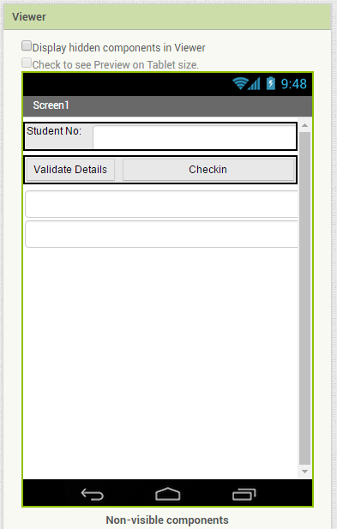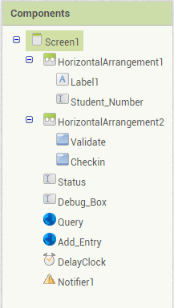

This example uses one web component for **Query**, and the other web component for **Checkin** (shown here as “AddEntry”)

This example uses a text box to obtain a student number. It then has buttons “Validate” and “Checkin” which will be activated depending on which activity is necessary.

**Blocks**

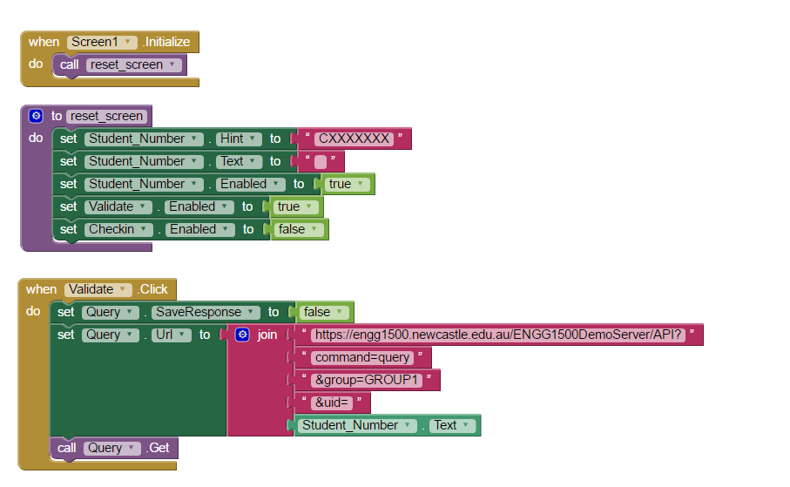

Here, the application uses a validation button click to build the query and send it to the server. Note that this uses the Query web component to handle the query communication.

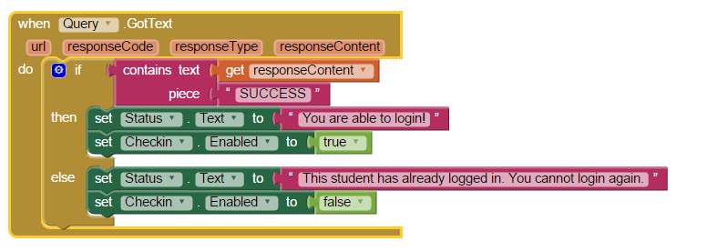

If the query is successful, the program can move onto the Check-in feature. This is allowed by enabling the “Checkin” button.

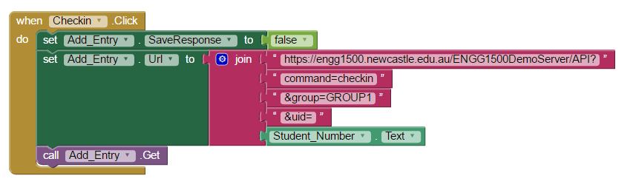

When the Checkin button is clicked, the command to checkin is built and sent to the server. Note that this time, the “Add_Entry” web_component is to handle the checkin commands.

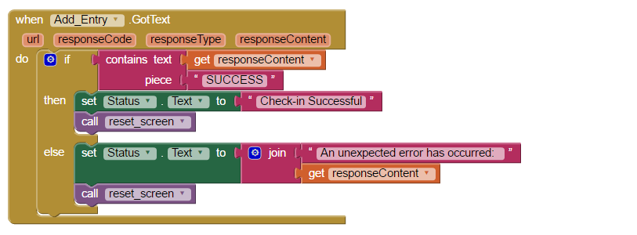

This reports on whether the student could Check-in (that is, was it successful). It then re-sets the screen should another student wish to log in from this phone.

Note that the example above is intentionally limited. This example is only to demonstrate the use of the two web-components in the one application. The application you and your group design will require more logic so that any user input (if used) is validated locally (i.e. within the application), as well as incorporating more features which have been demonstrated in tutorials, or features found using your own research.

## Useful Development Feature

During development, it is possible you may wish to include a debugging method, which will help you determine the cause of any unexpected application behavior.

**Designer**



**Note that this text box should be removed before the application is submitted for marking.**

A text box at the bottom of the screen can be populated with debug information if/when required.

**Blocks**

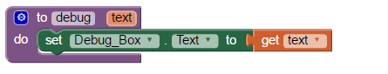

A debug method can be made which takes some text as input. That text will be displayed to screen.

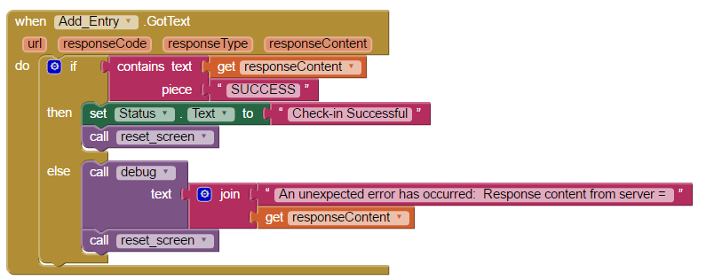

This method can be called from any part of your program, where unexpected behaviour occurs. This will give you more information, so that you can determine the cause of the error.